Arduino Setup

# Mounting boards

There should be two Arduino boards, the base ‘Uno’ board, which stores the program, records data and sends information out. Then the ‘Motor Shield’ which slots on top and takes on/off signals from the base board. This can handle the high currents coming out of a large power supply required to power the motor.

However this top board can also take power from the lower board, so we need to knock one of the pins out so that it can only take power from the supply and doesn’t get confused.   
  
So before mounting the board, bend the ‘Vin’ pin slightly inwards as shown below:

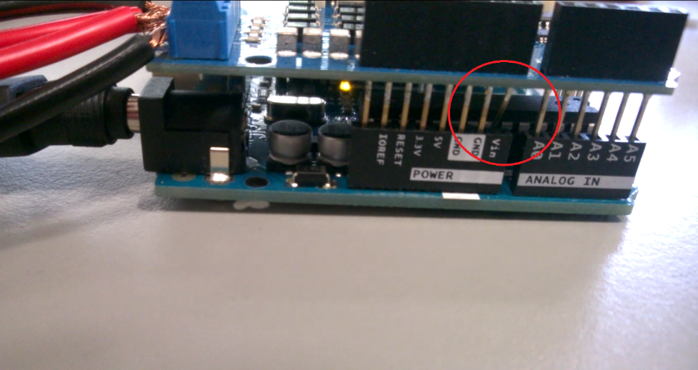

Now you can mount the board on top. Upload the program to the board by first opening it in the Arduino program. Now connect the appropriate cable from the usb port on your computer to the input port on the bottom ‘Uno’ board (the one that isn’t the power supply!).

# Load Program

Once this is in try pressing the ‘upload’ button highlighted in the next picture. If this doesn’t work and you get an error message, you will need to select a different port. Go to **tools > port >** and select a different one (I think ours was COM1, but try them all until it works).

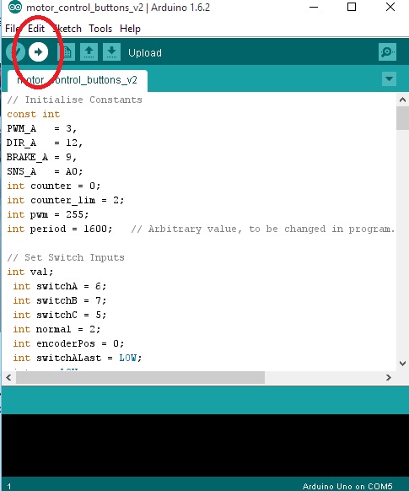

# Wire up the board

The buttons and power supply now need to be wired up. The red and black cables which connect to the power supply need to be wired to Vin and Gnd respectively (see below, bottom left). Channel A is used to control the motor, so wire the two other black and red wires which connect to the motor into + and – in this channel. It doesn’t particularly matter which way around as it will just run backwards.

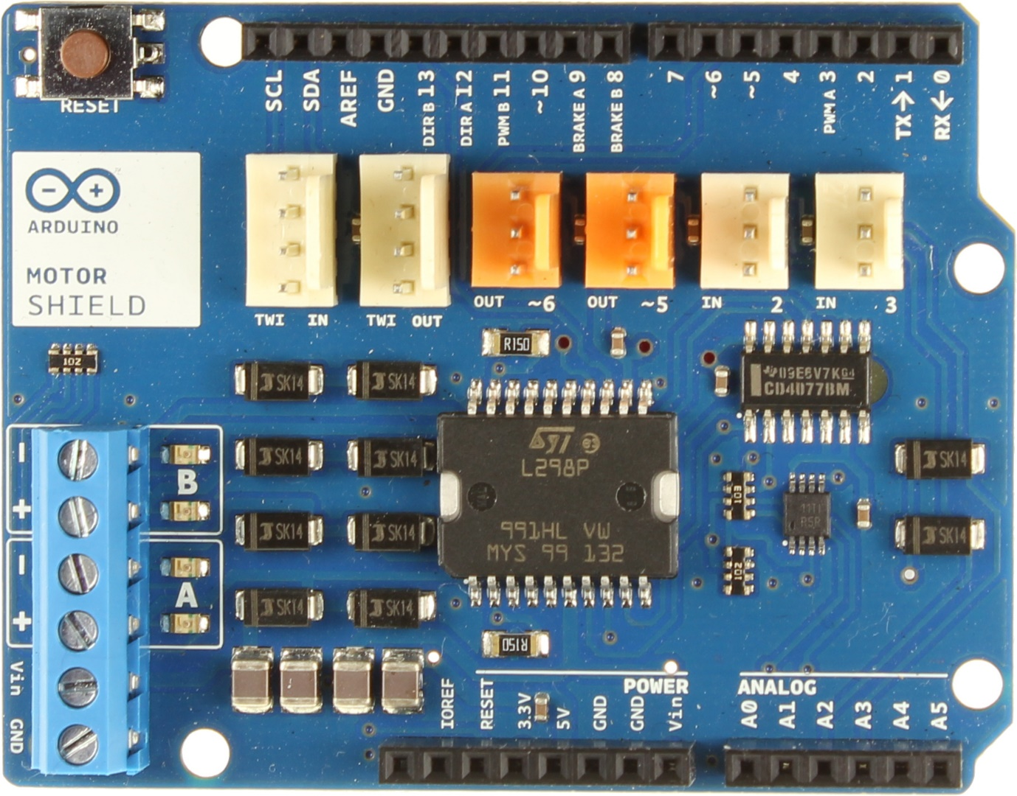

You will notice that one terminal of each button is wired to all the others. This common terminal needs to go into one of the ‘GND’ holes in the motor shield – right next to the Vin button that you bent earlier. The others need to be wired as follows:

**TOGGLE SWITCH**: Port 2  
GREEN BUTTON: Port 6  
RED BUTTON: Port 7  
**BLACK BUTTON:** Port 5

This should be everything that needs to be done to get it back to its original state. You can now cover the boards up with the box and use it as normal.